**Terraform EC2 NGINX**

Create 2 EC2 instances on 2 different regions and install nginx using terraform script

Step 1: Creating Folder in Visual studio to create terraform files

* Folder: ec2-multi-region

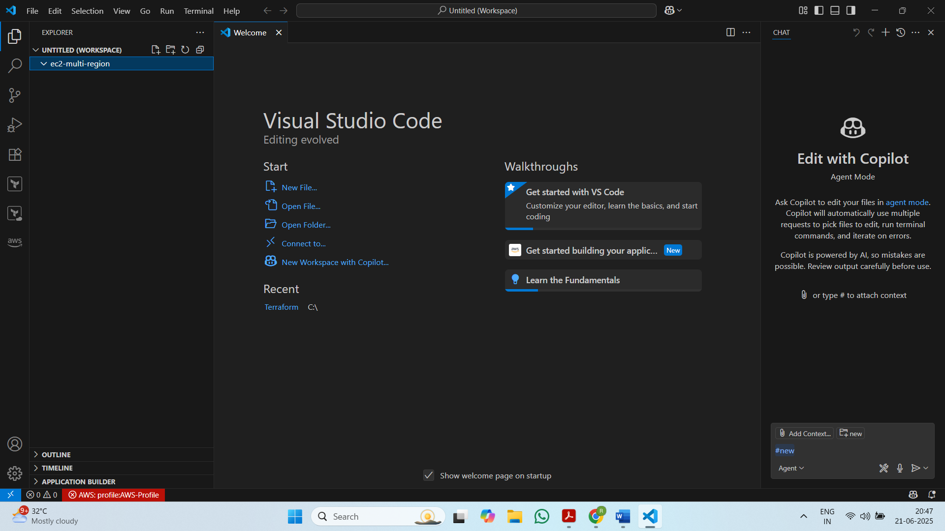

Step 2: Create 2 key pairs in 2 different regions and Access Key

* 1st key pair: us-east-1

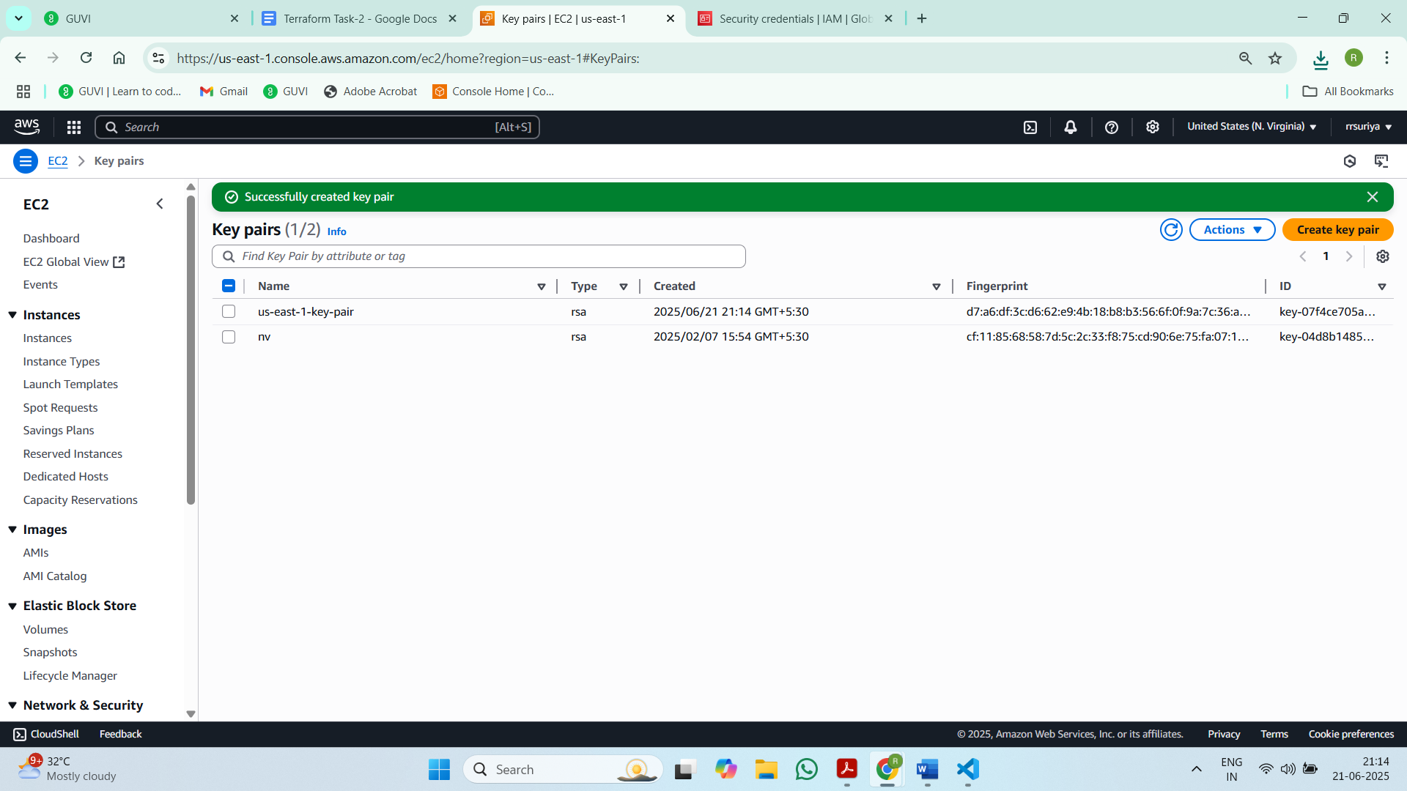

* 2nd key pair: us-west-2

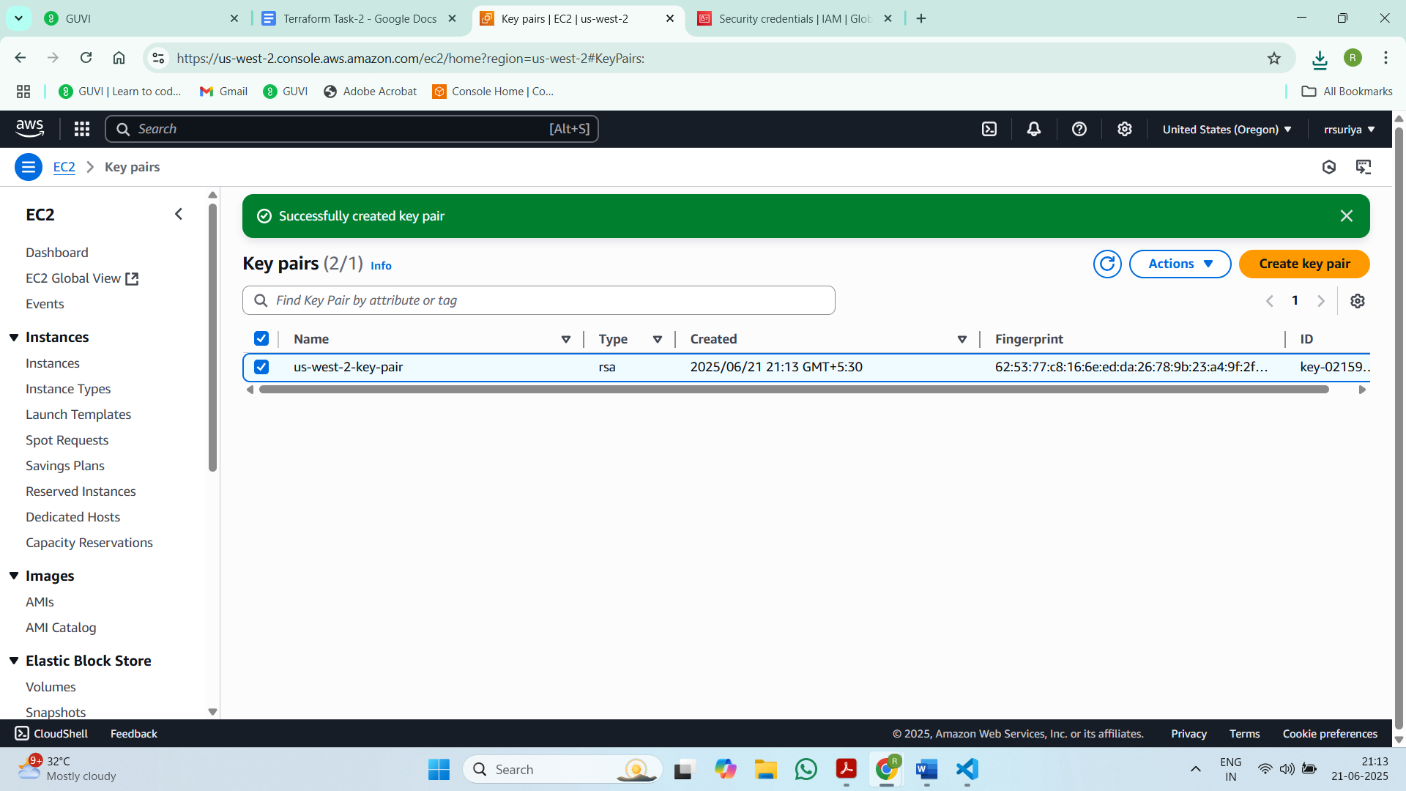

* Access key

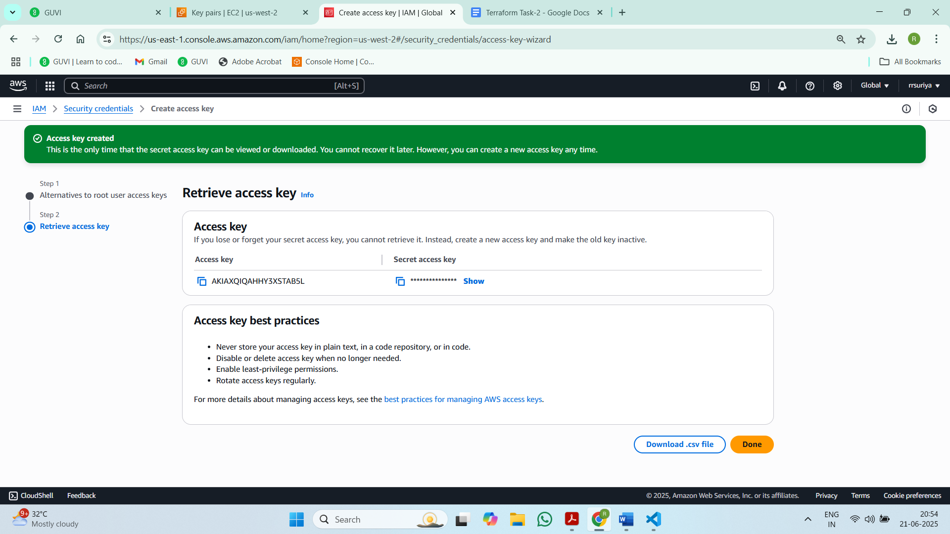

Step 3: Create variables.tf, main.tf and output.tf files

* Now Create the variables.tf file inside the folder ec2-multi-region and define it

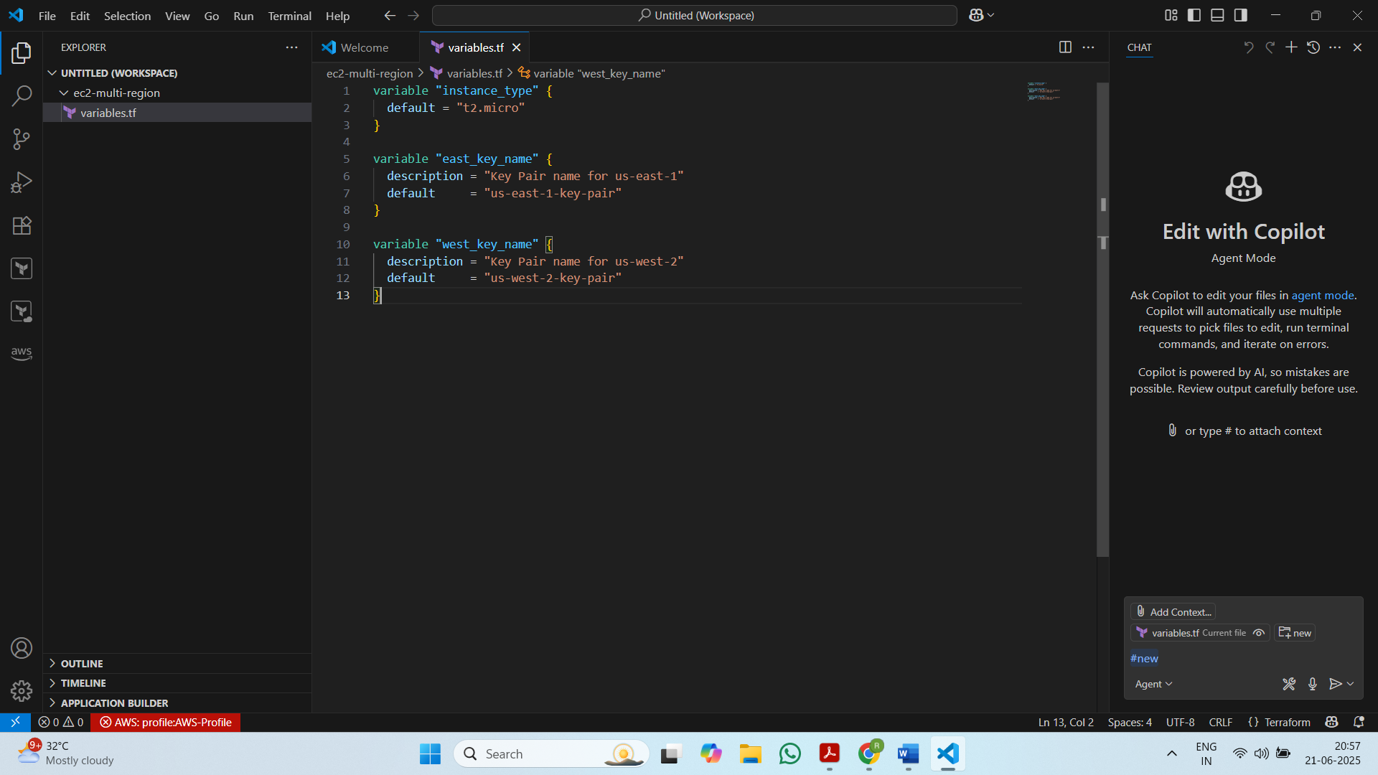

* Create the main.tf file to provide the terraform script to Create 2 EC2 instance in 2 regions and installing Nginx on them

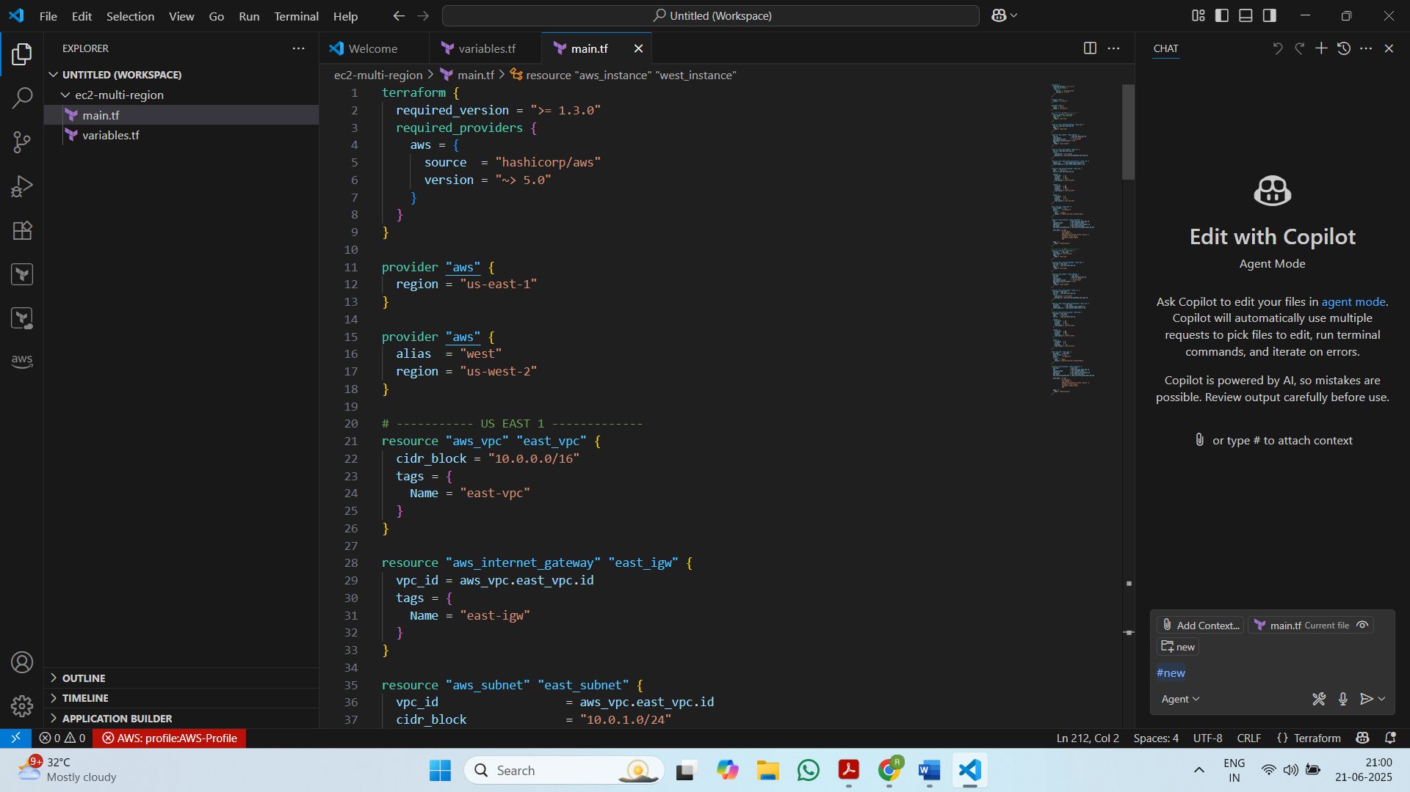

* Create output.tf file

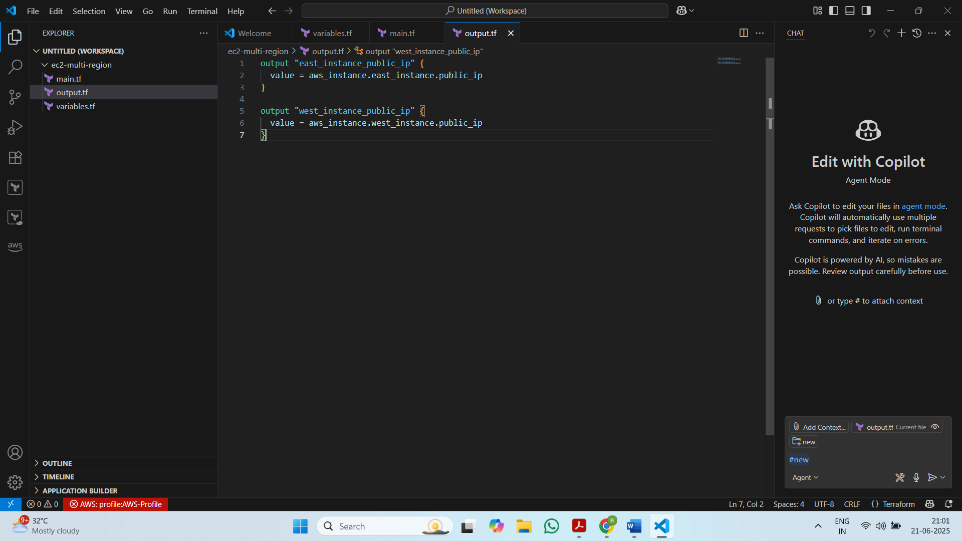

Step 4: Configuration

* Terraform version

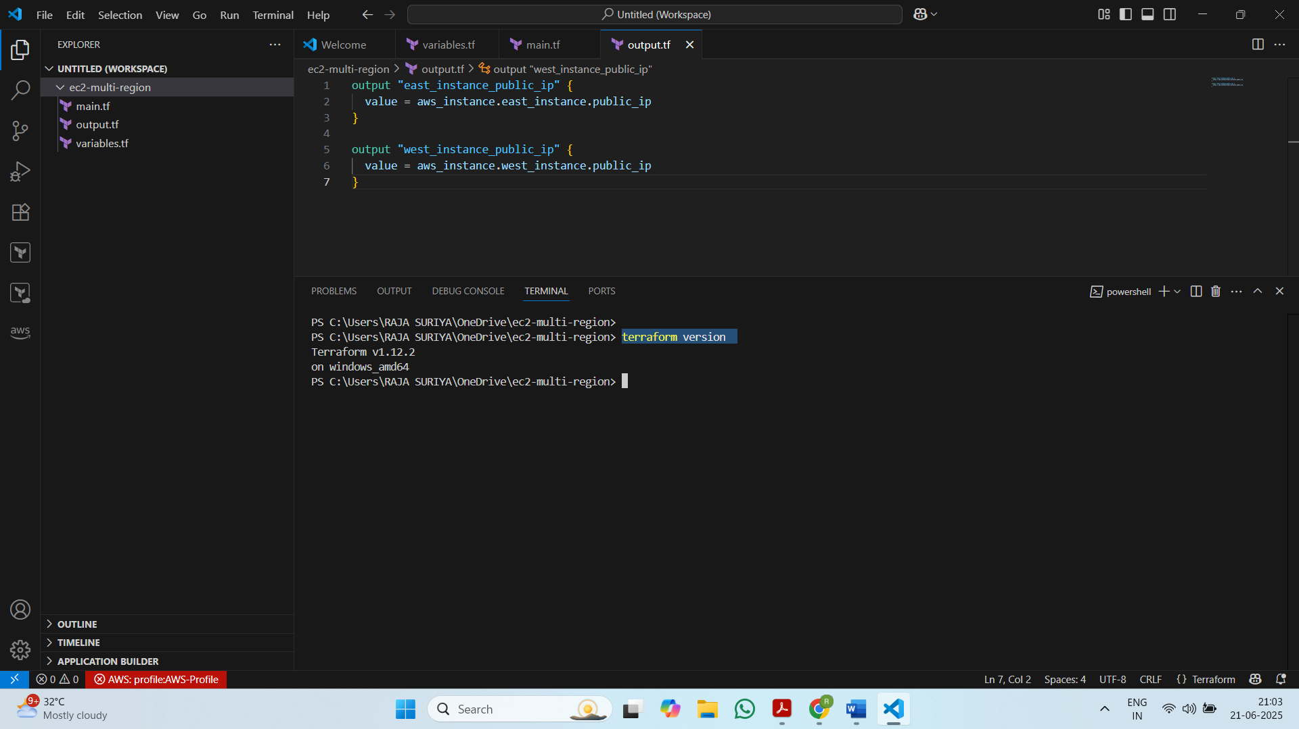

* Aws version

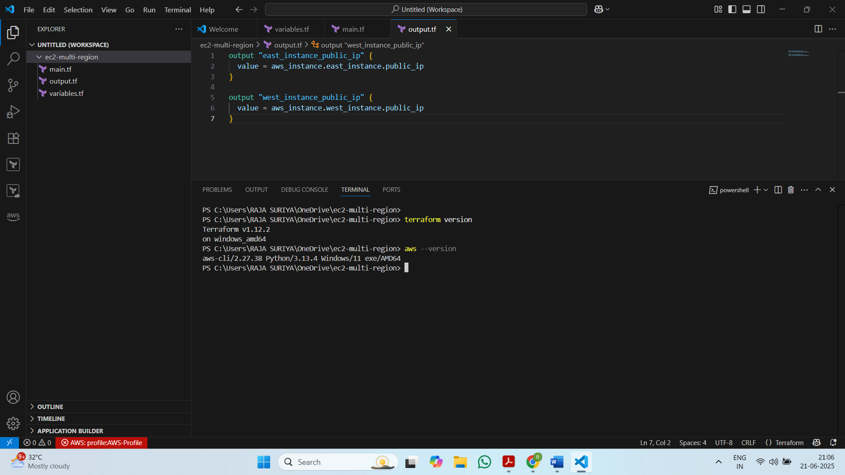

* Aws configure

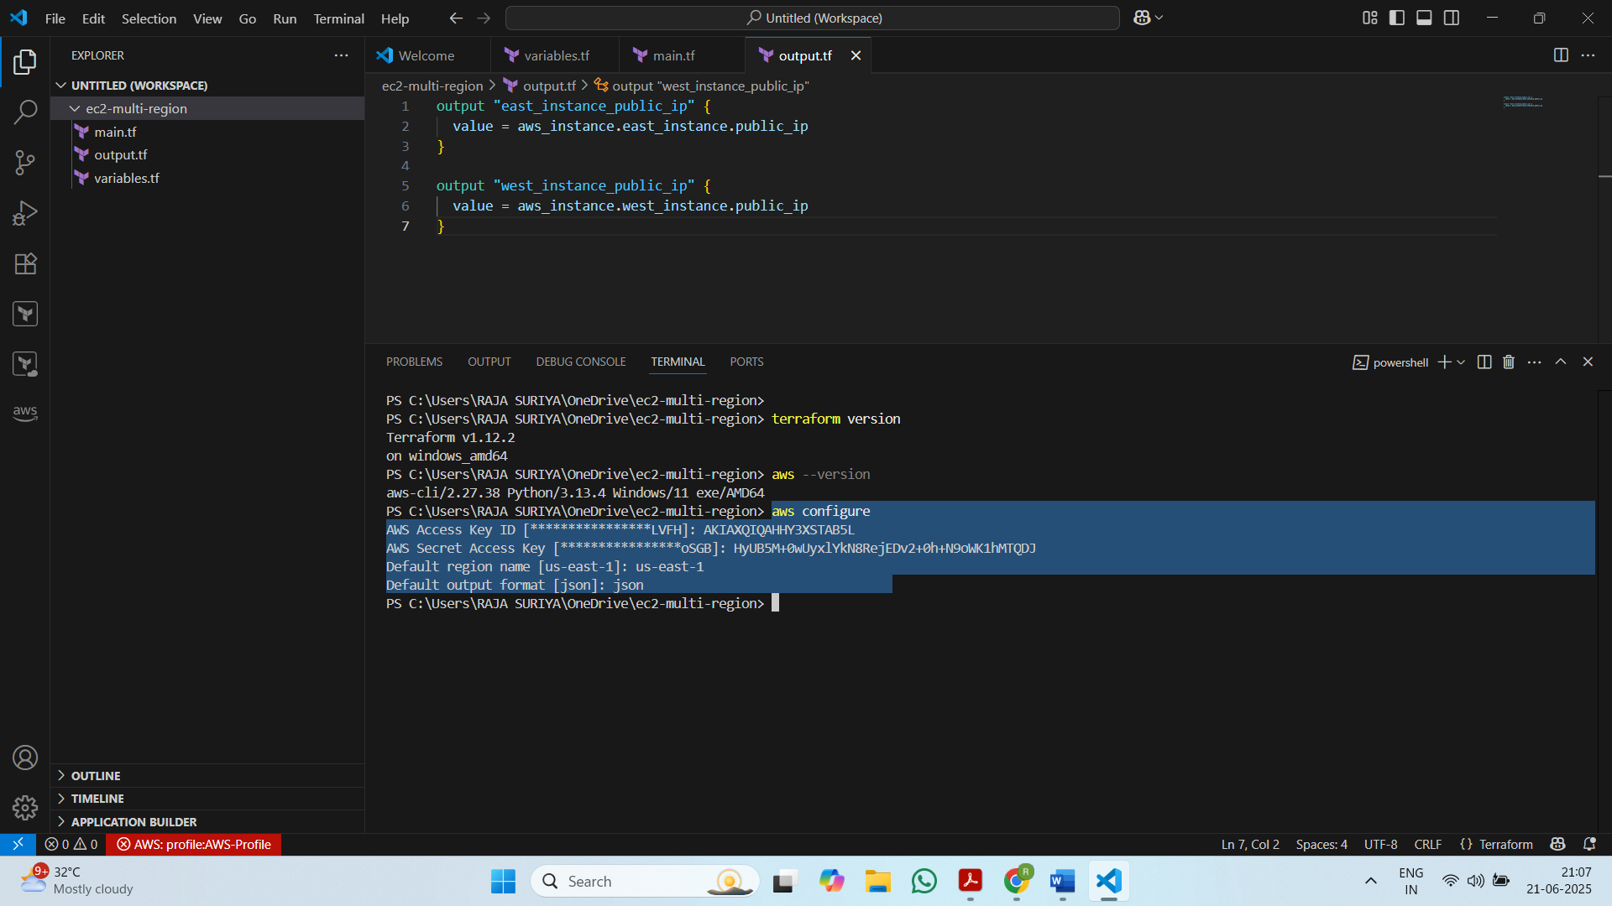

* terraform init

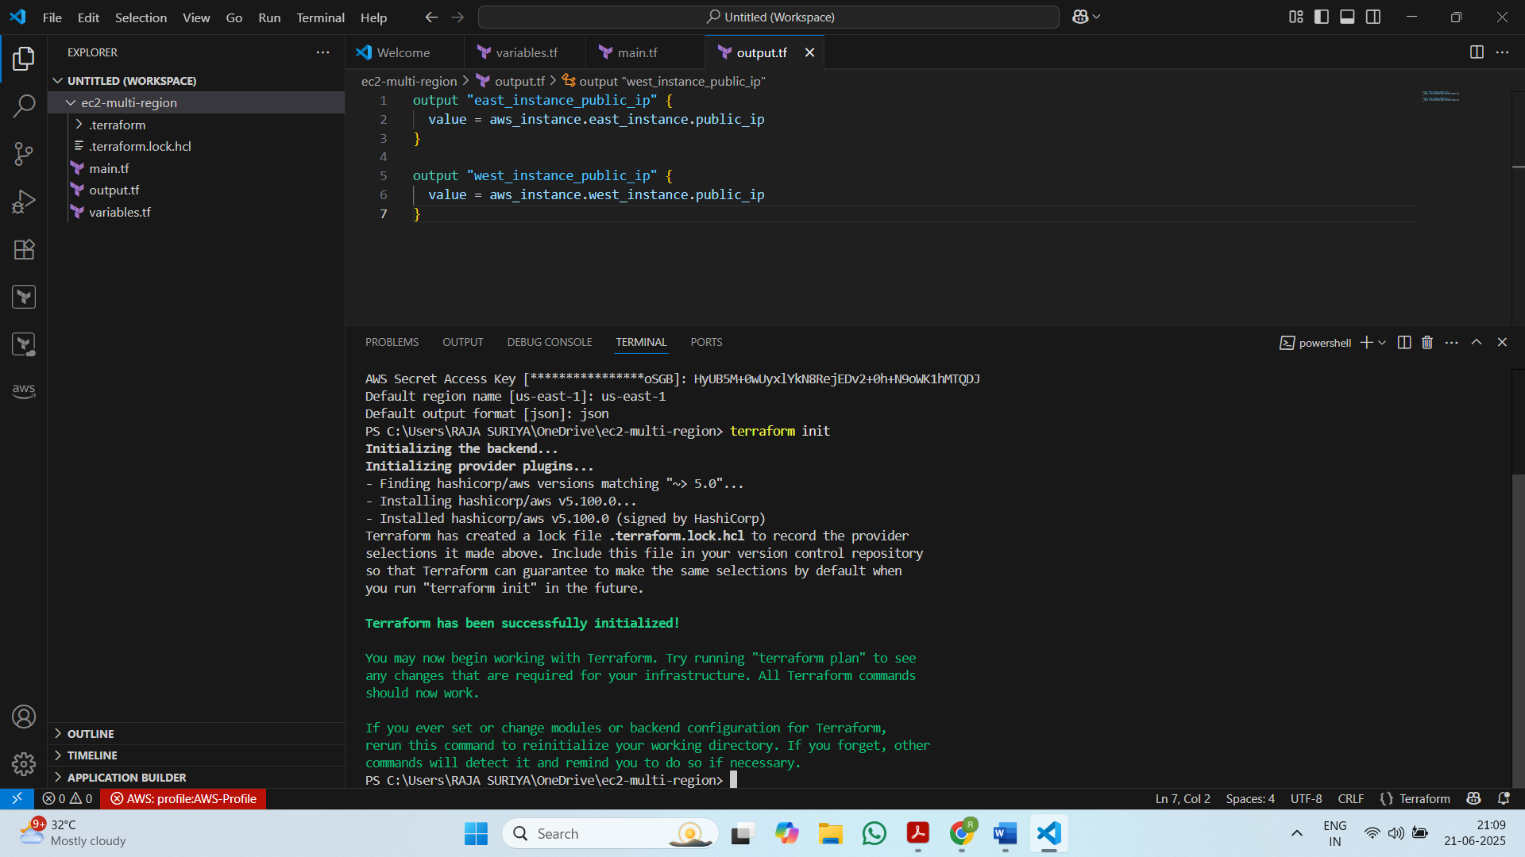

* terraform validate

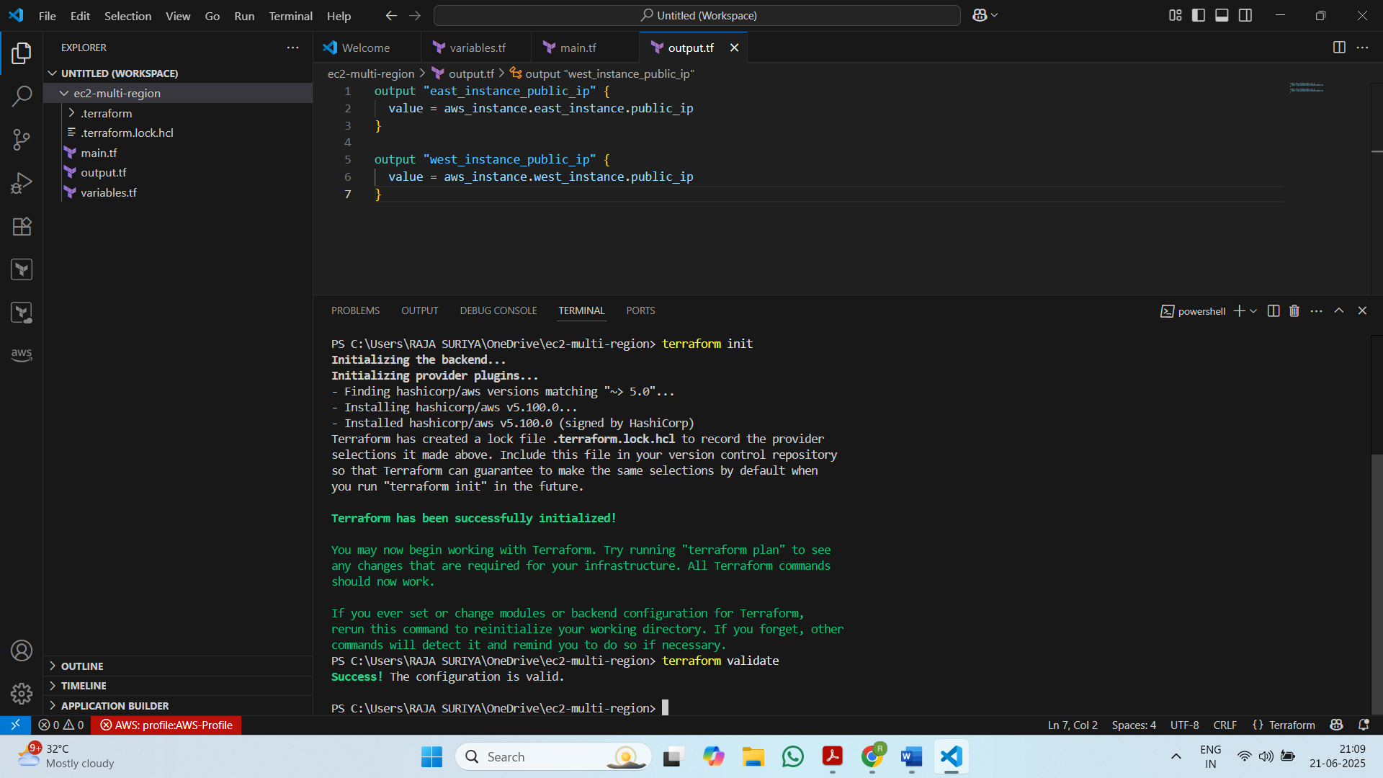

* terraform plan

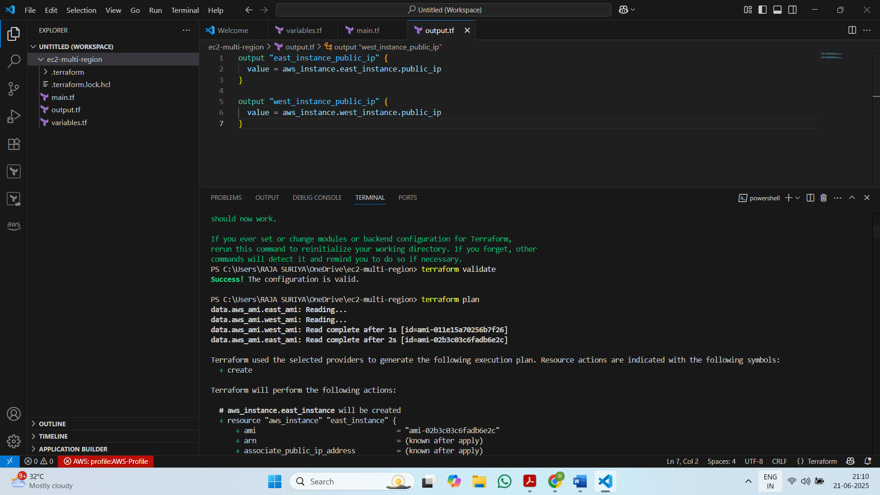

* terraform apply

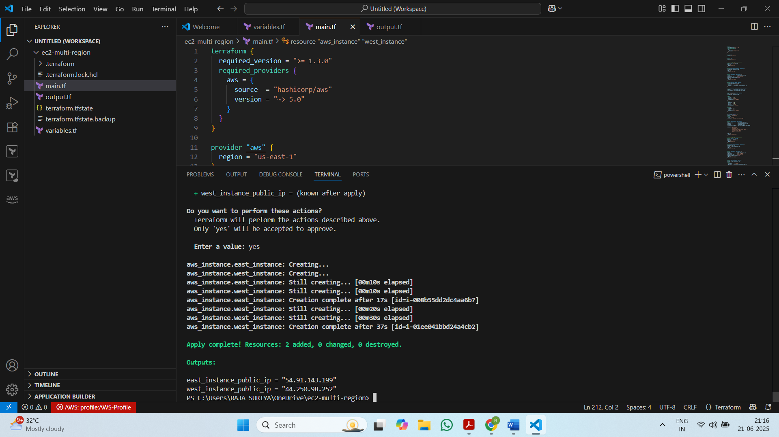

**APPLY EXECUTION DONE SUCCESSFULLY**

Step 5: Verify Instances Creation in 2 regions

* us-east-1

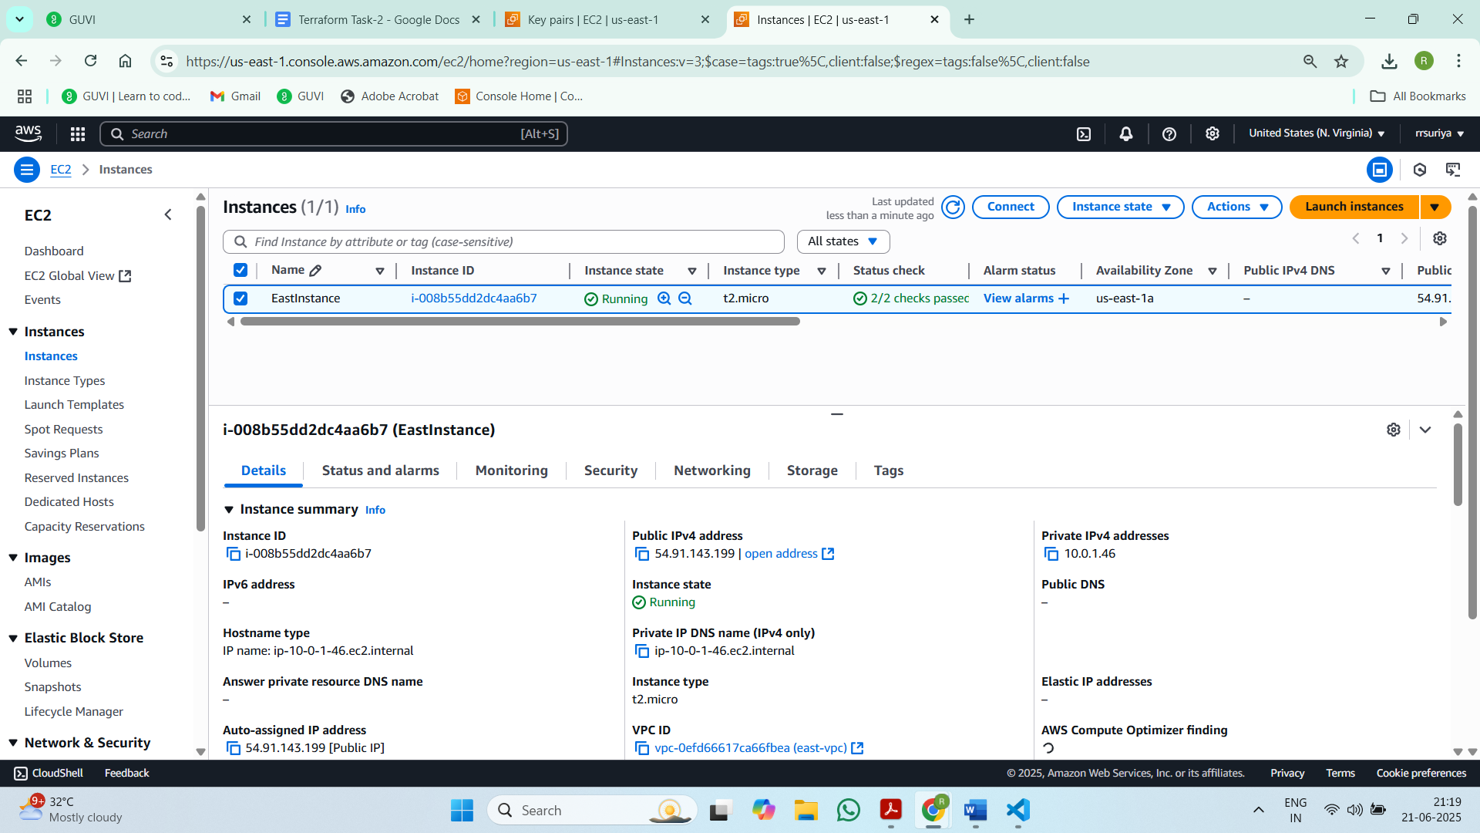

* us-west-2

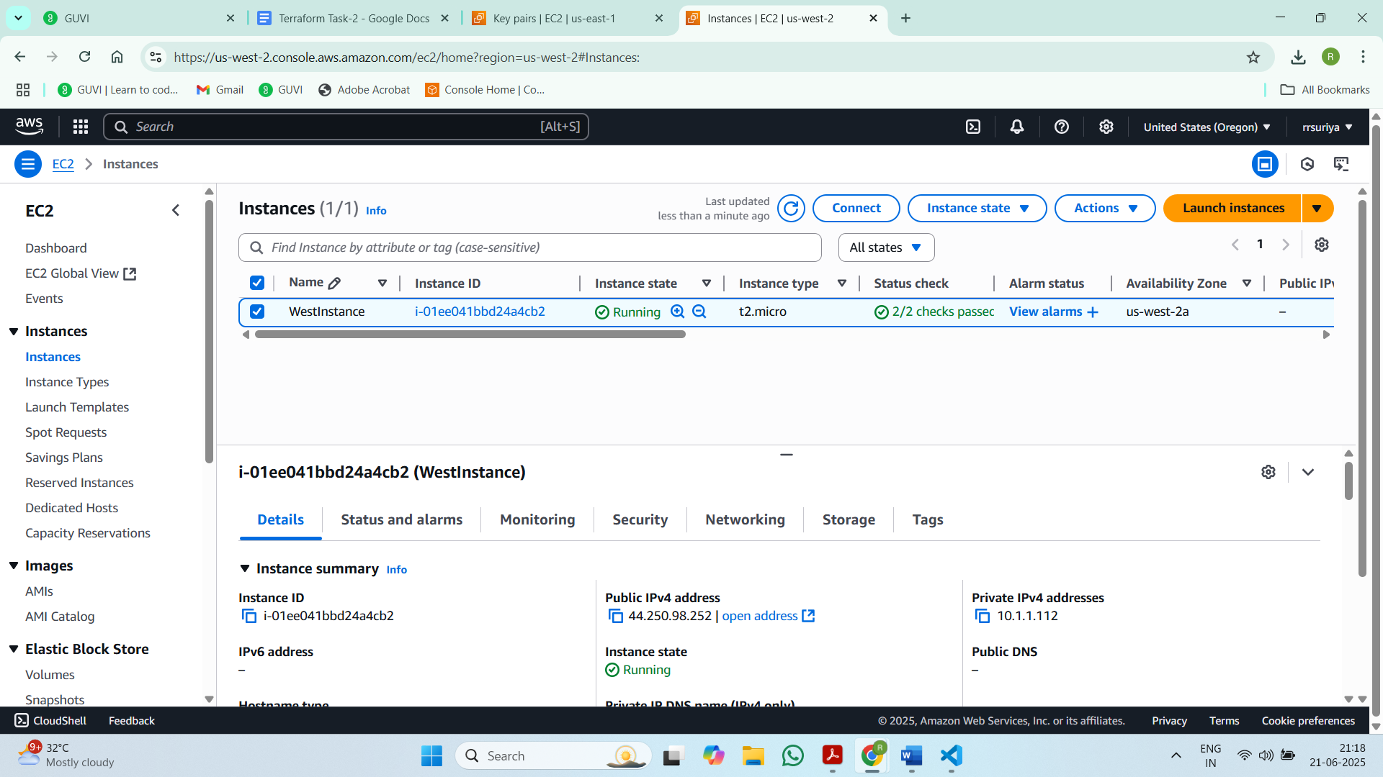

Step 6: Verify NGINX Installation in both instances

* us-east-1: ip - 54.91.143.199

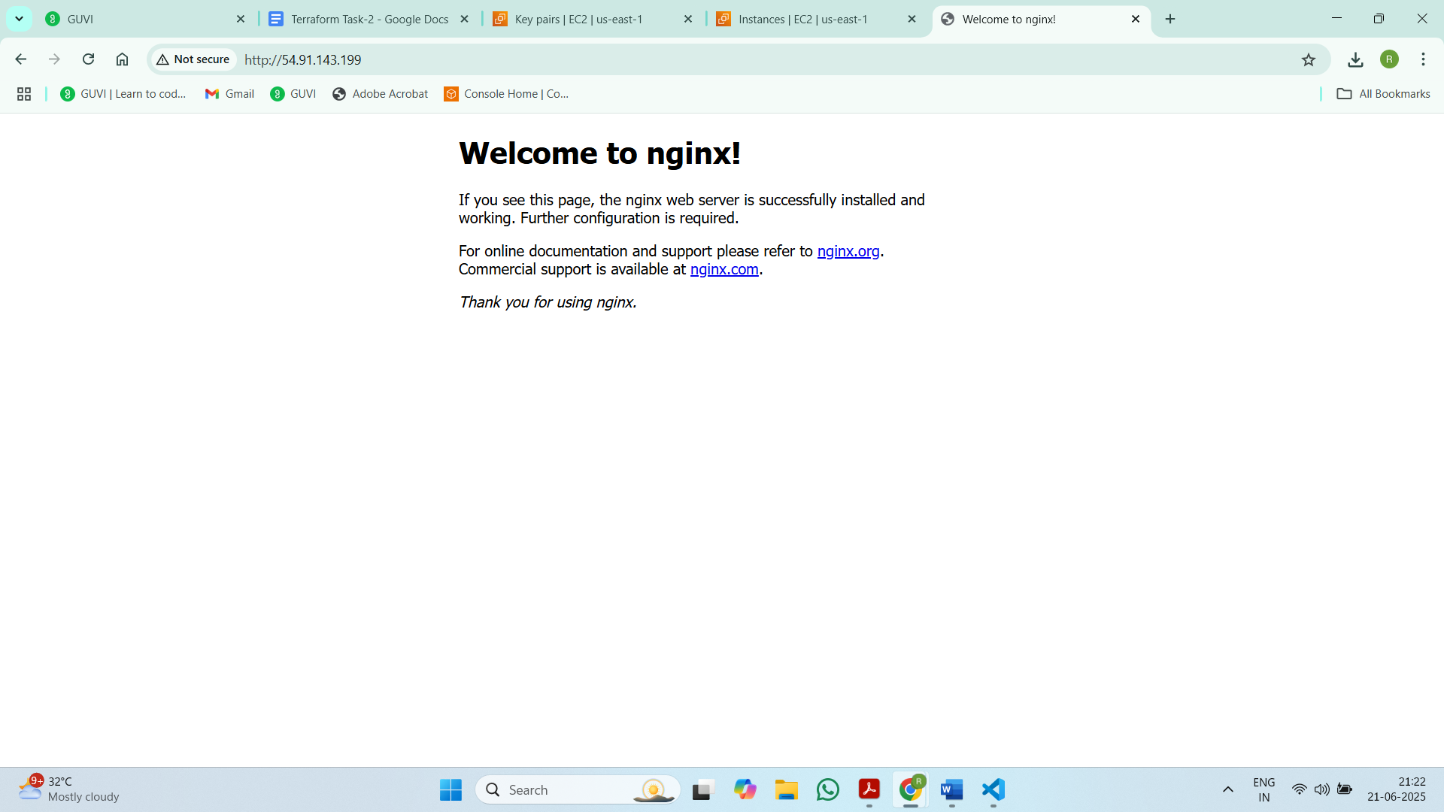

* us-west-2 : ip - 44.250.98.252

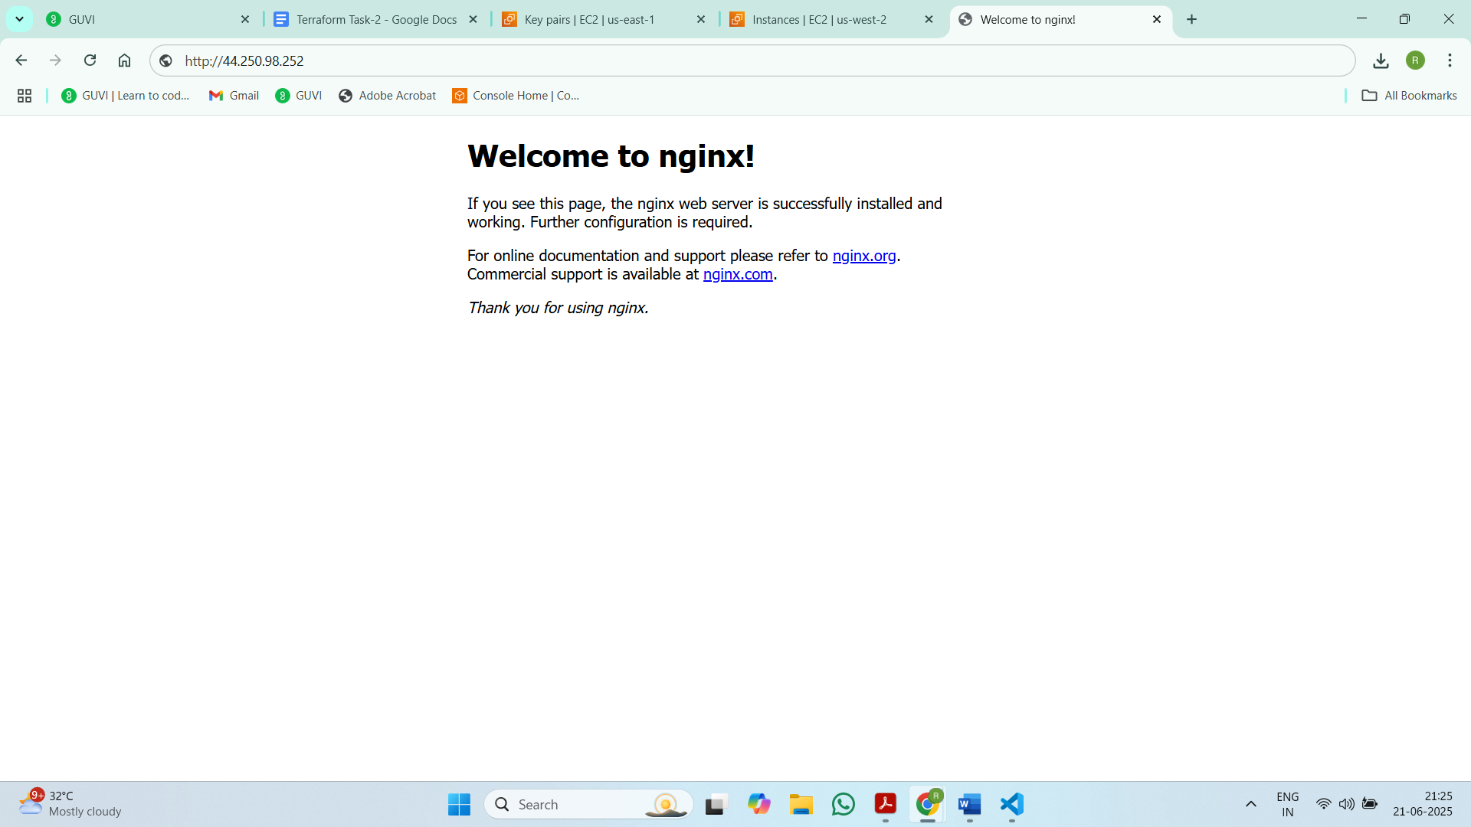

Step 7: Destroy Terraform (if needed)

* terraform destroy

